64

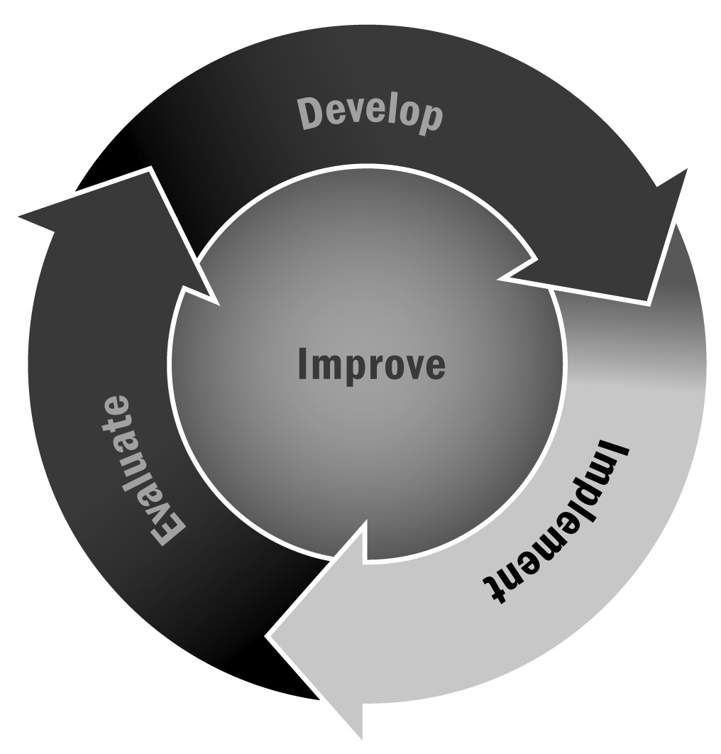
Sample Youth Satisfaction Survey
In Chapter 4, you learned that to be effective, youth development programs require careful and thoughtful planning and work best when young people are included in the planning and ongoing improvement of the program. There are many ways to get feedback for improvement, including reflections and check-in times, and through individual meetings. Another good way to get youth feedback is via satisfaction surveys.
Directions: To understand how young people are experiencing your program, you can ask them directly by using a short survey. In this tool, we provide some tips for conducting good surveys and provide you with a sample survey and question bank that you can use or adapt based on your needs and the age of the respondents.

Tips for Conducting Good Surveys
See Tool 87: Tips for Developing and Administering Surveys for more ideas.
- Keep a satisfaction survey like this one to one double-sided page. Too many questions will make it hard for you to use the results, and youth may lose interest.
- For younger youth, ask only multiple choice questions. You can use open-ended questions for older youth, but limit them to two or three.
- Make sure your questions are easy to understand and are developmentally appropriate for your audience.
- Be specific in your questions and ask only one thing in each question.
- For youth in grades K–2, adults should ask youth the questions and record their answers.
- Use a three-point rating scale for youth in grades 3–6 and a four-point rating scale for youth in grade 7 and up. Sample rating scales are given below for your use. You can cut and paste the appropriate scale into your survey.
For youth in grades 3–6, use this rating scale:
Always | Sometimes | Never
For youth in grades 7 and up, use this rating scale:
Always True | Often True | Sometimes True | Never True
4 | 3 | 2 | 1

Sample Survey Items
Logistics:
- The program schedule works for me and my family.
- I get to help make decisions about things like rules in the program.
- I know what is expected of me at this program.
Open-ended question:
- What, if anything, would you change about the program schedule?
Staffing:
- The program staff helps me learn new things.
- I feel that the program staff respects me.
- When I do well, the program staff members give me positive feedback.
- The program staff knows my name.
Open-ended questions:
- What would you change about the adults in this program?
- What do you like most about the adults in this program?
Activities/Content:
- I am given choices about activities in my program.
- I like coming to this program.
- I have fun when I am at this program.
- I have opportunities to lead activities.
- I feel bored when I come to this program.
- I can always find things that I like to do here.
- I feel challenged in this program.
Open-ended question:
- What kinds of activities would you like to see offered in this program?

Program Environment:
- I feel safe at this program.
- I feel I belong at this program.
- I feel comfortable with the other youth in this program.
- I learn about positive ways to resolve conflicts in this program.
- Kids in this program treat each other with respect.
Open-ended questions:
- What do you like most about this program?
- What do you like least about this program?

